Clone the Team Repo and the Shownow source code repo to my PC, using the wsl,
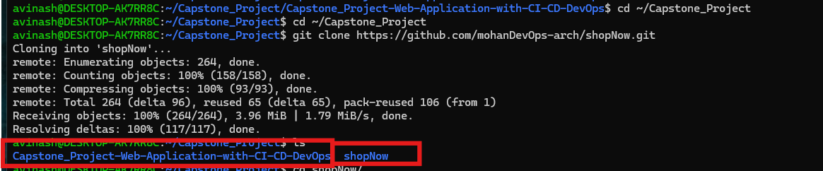
Go th o the shop now folder and verify the each code and doker file ,
Like Fornt end , Back end and Admin,
-Setup the Docker
Check the docker version
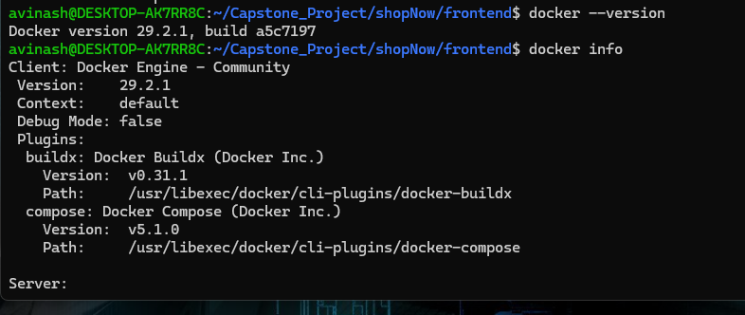
In the shopnow –goto the front end folder and duplicate the Docker file as a Version v1
Same as for the Backend and Admin files,
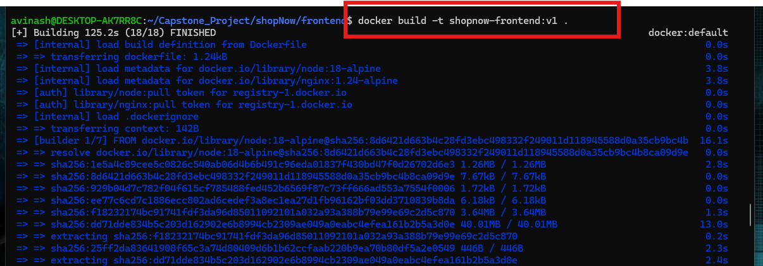
After run the docker build command , check the docker images , I should show the all the three shopnow applicatins which we clone it as v1
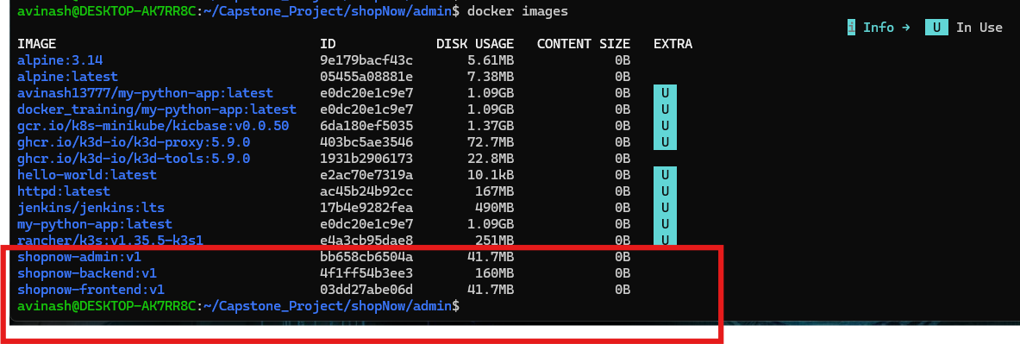
Opne the docker backedn Docker filr and check the Port We use the Port 5000
Now run the docker run -d and run the image in backedn
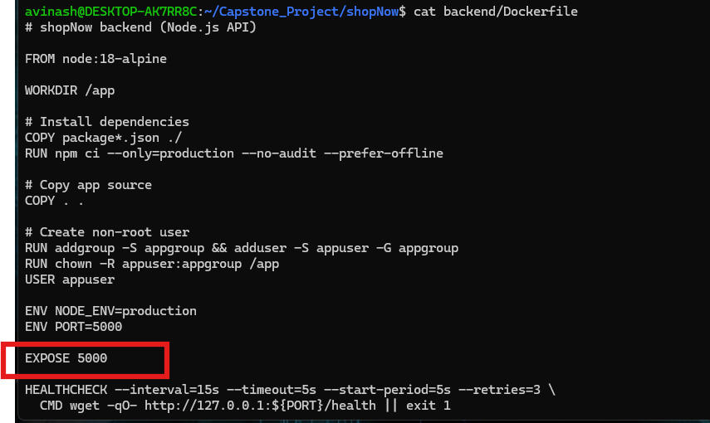
Docker backend image is running
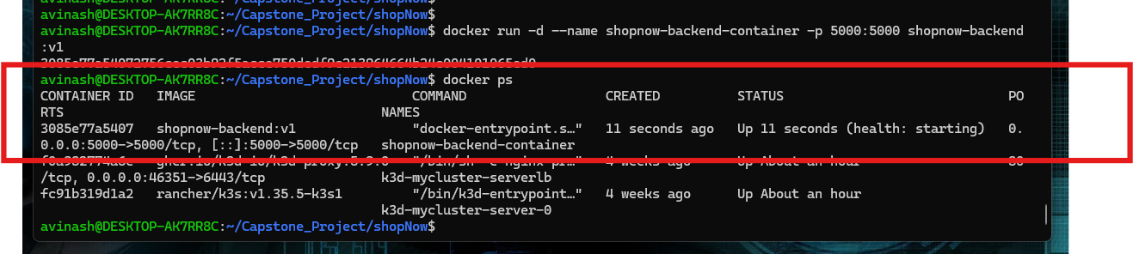
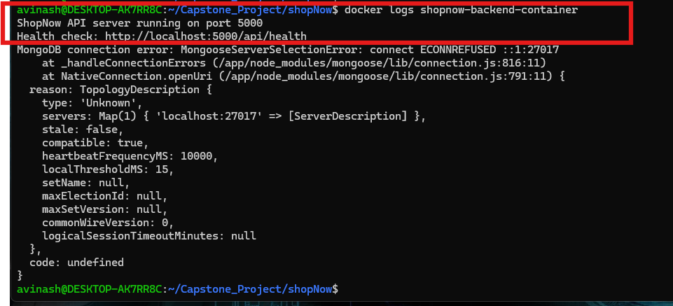Tested and it is running
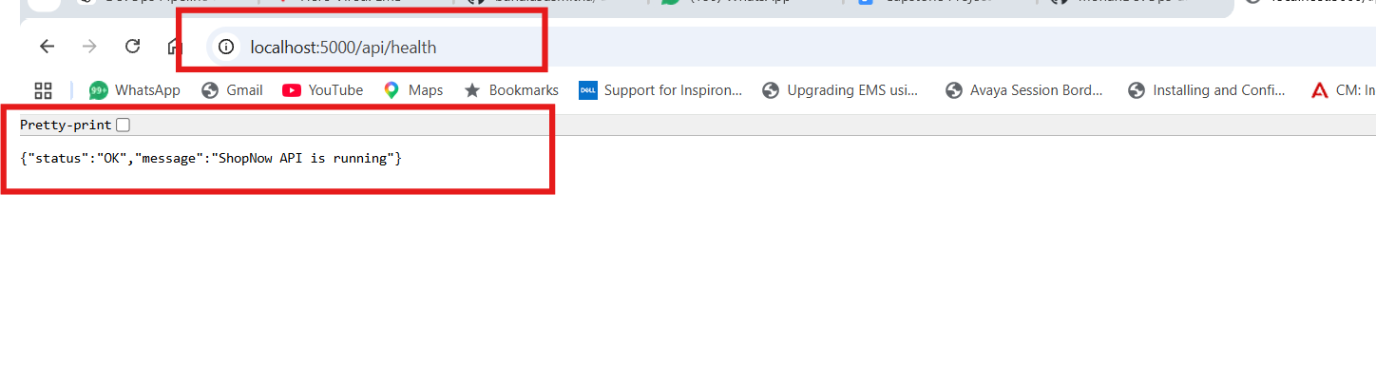

Run the front end and admin also ,

But it is getting fail ,
Check the docker logs
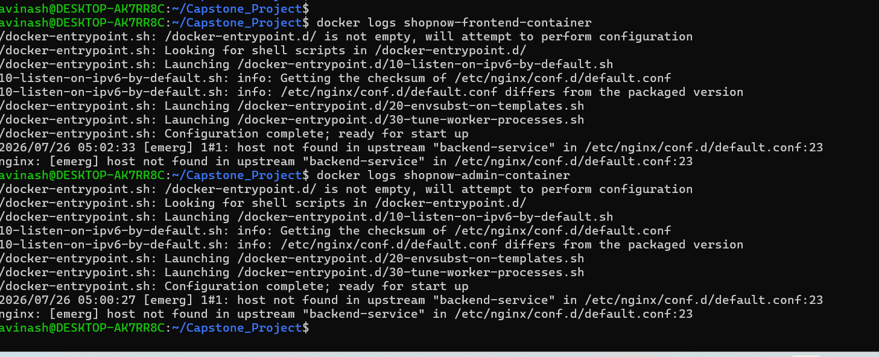

The frontend is not designed to directly talk to a Docker container. It is designed to talk to a Kubernetes Service due to thatit isgetting fail ,

Built Docker images successfully for frontend, backend, and admin. Backend container starts successfully (MongoDB connection expected to fail until the database is available). Frontend and admin images build successfully, but the containers exit locally because the Nginx configuration is designed to proxy to the Kubernetes Service backend-service, which doesn't exist in standalone Docker. This is expected and should work once the application is deployed on Kubernetes with the corresponding Service.

Next step:

Day 2

✅ Push Docker Images to Amazon ECR
✅ Create Kubernetes Deployment YAML files
✅ Create Kubernetes Service YAML files
✅ Deploy to Amazon EKS
✅ Verify the application

Docker Images
│
▼
Amazon ECR
│
▼
Kubernetes Deployment
│
▼
Kubernetes Service
│
▼
Pods Running
│
▼
Application Accessible

Install the aws cli-
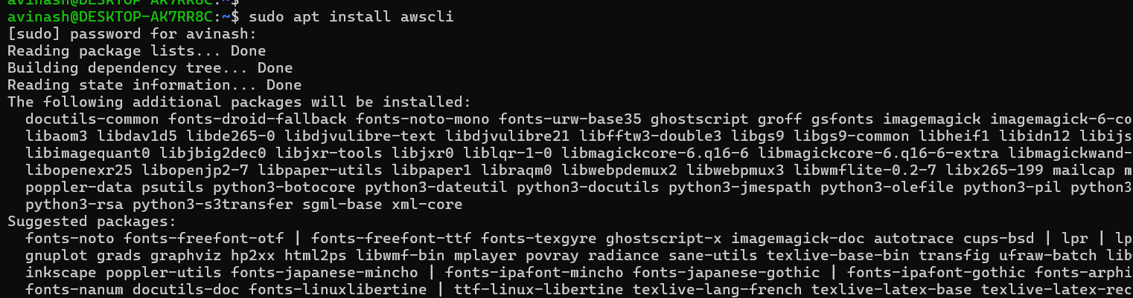

After install aws cli, we configure the aws IAM account to the aws with Access key and screat password,
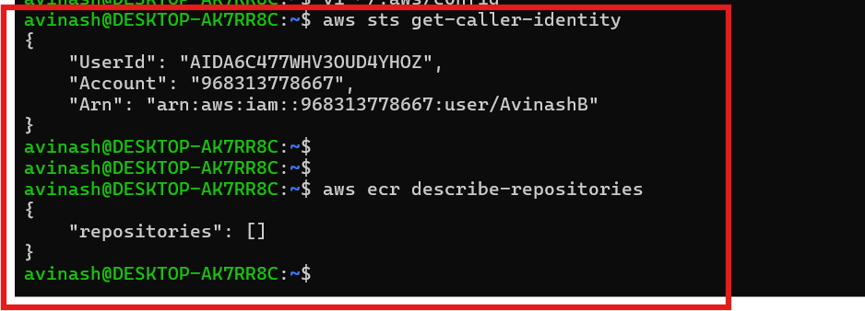
Currently the Docker images are in the local PC, so now we are going to install in the Aws ECR,

Creat frontend:
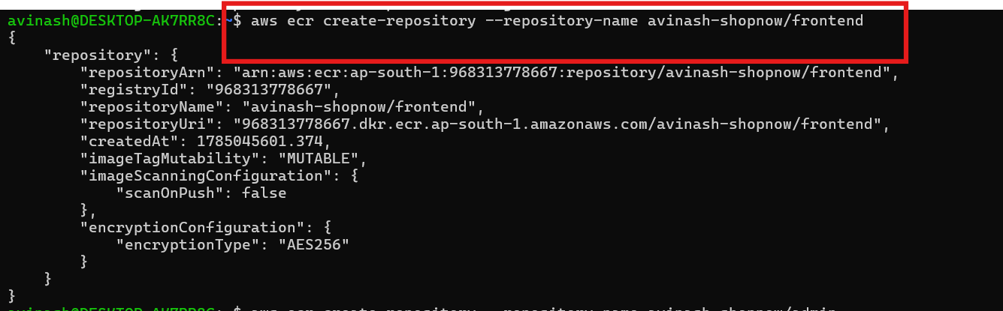
Create Admin and Backend :
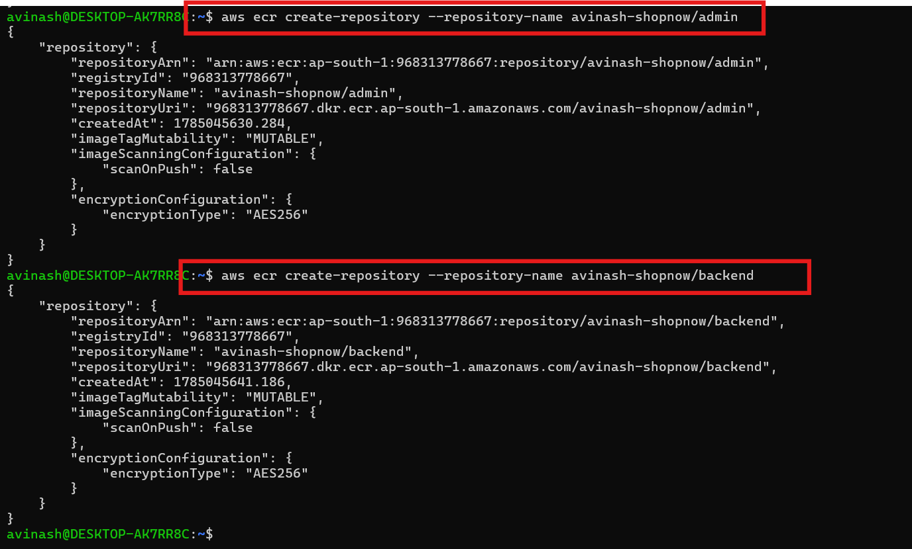

WE tag the images front ned backend and admin one beform pushing ,

Login to Docker into ECR,
And uushed the all the three images
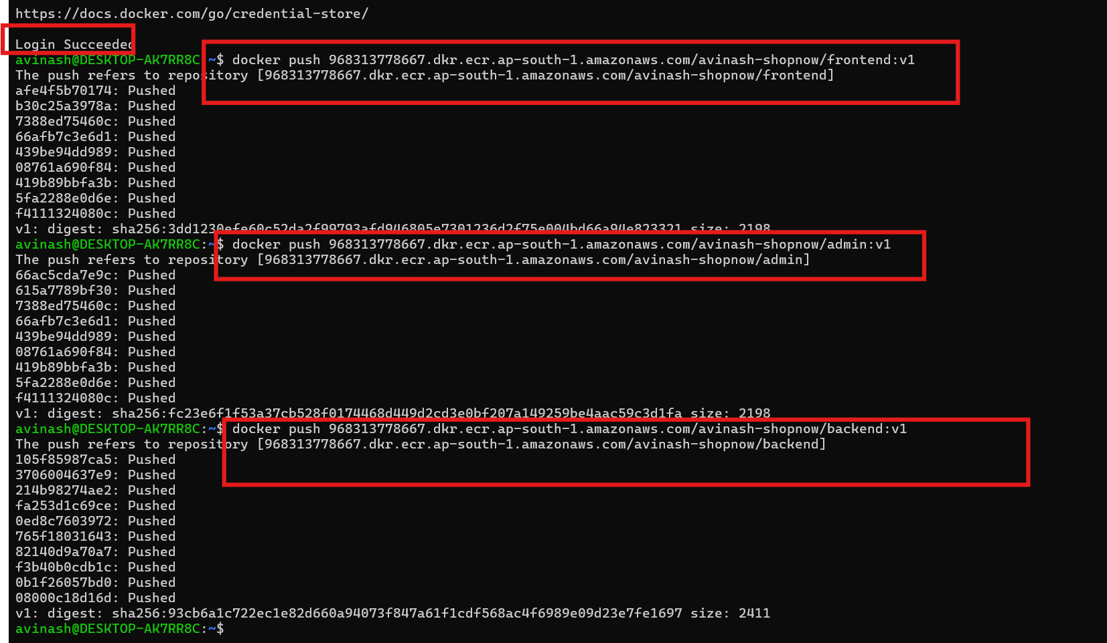

Now Kubernetes Part,

Created the floder and creating the backend front and admin .yaml files for deployment and services

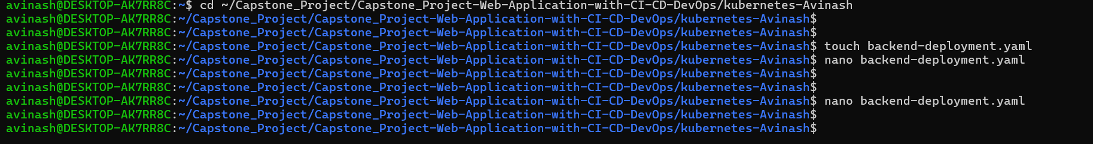

Backend:
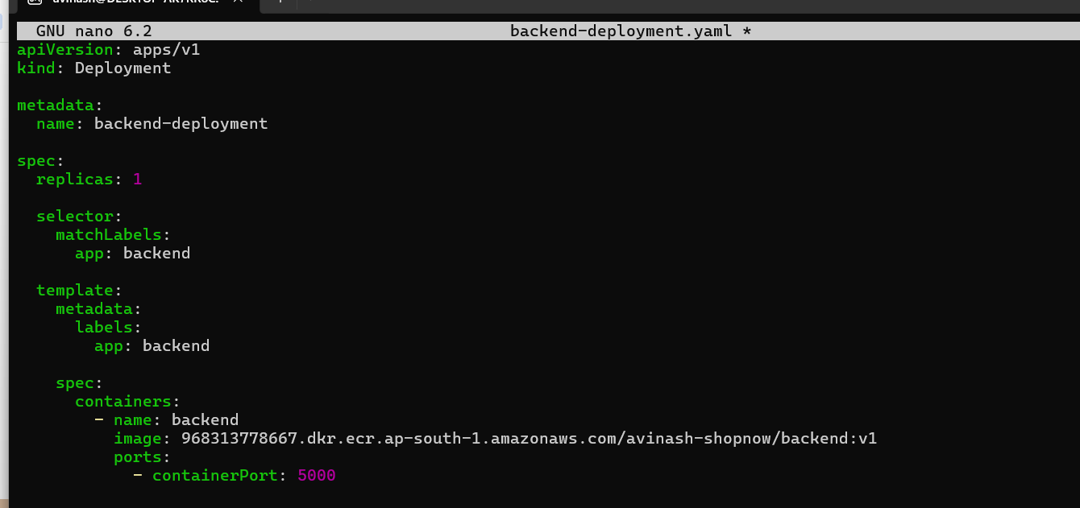

Backend service .yaml file:
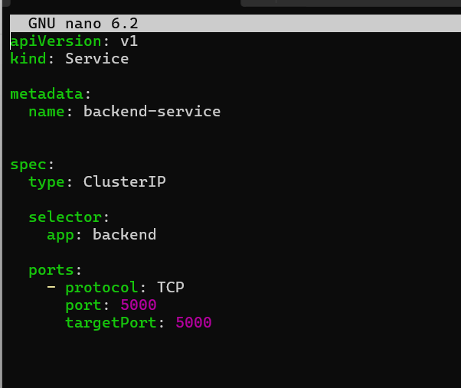

Frontend-deploymet .yaml :

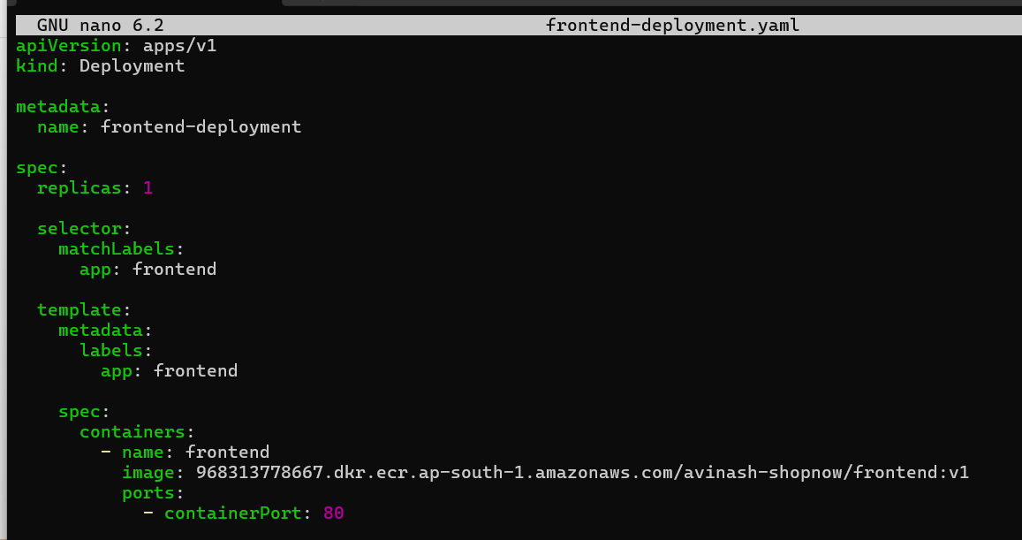
Frontend-service.yaml:
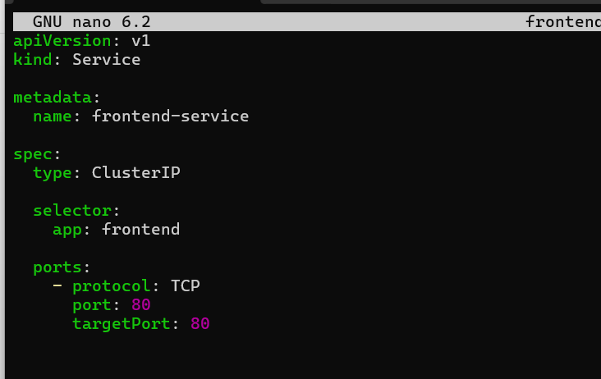

Admin-deployment .yaml:
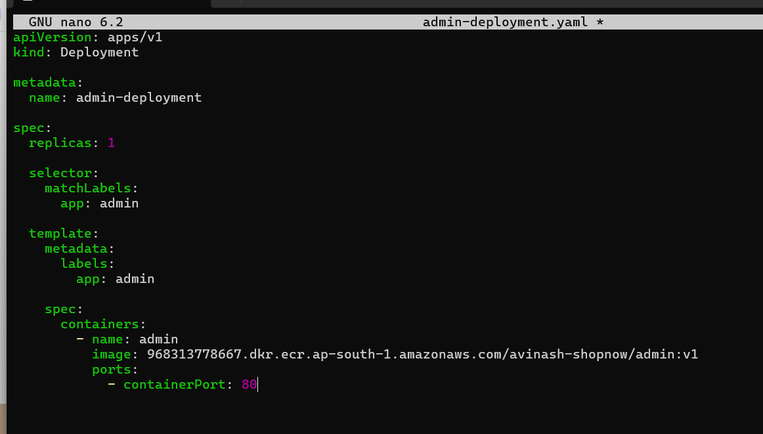

Admin-service.yaml:
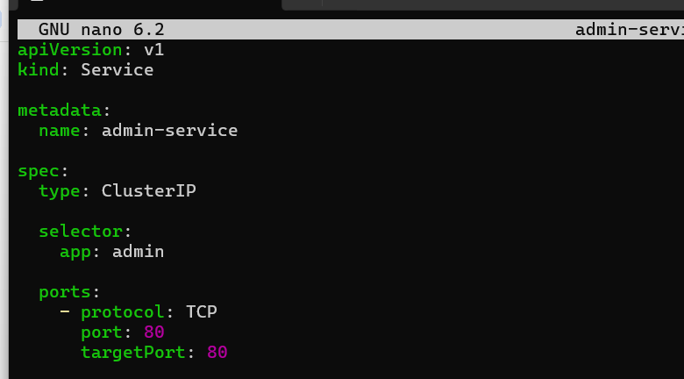

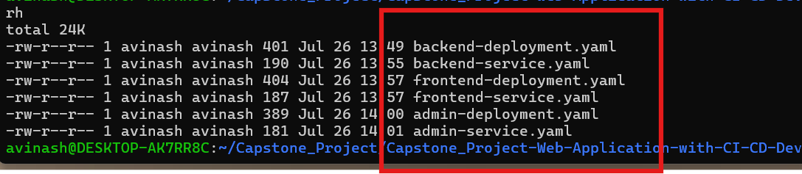

All the .yaml files are created

